

PROJECT TITLE- MUSIFY

DECLARATION

We hereby declare that the project entitled - “Musify”, which is being submitted as a mini project for the 3rd semester in DATA STRUCTURES AND ALGORITHM in Information Technology department to JAYPEE INSTITUTE OF INFORMATION AND TECHNOLOGY (JIIT) Sec-62, Noida is an authentic record of our genuine work done under the guidance of Mr. Vivek Kumar Singh and Ms. Ankita Wadhwa.

Date:14th December, 2021

Members:

1. Aman Kakkar (20104043)

2. Shreya Garg (20104031)

3. Samridhi (20104054)

4. Tanisha Mehrotra (20104035)

PROBLEM STATEMENT AND OBJECTIVES

We aimed at creating a music player in which we can create, edit and delete our own playlist. We can also shuffle the songs or play the songs on loop. Moreover, we can see our search history just by going to the recently played option available. Our main objective is to create a user -friendly interface for better interaction with the musifiers. Our application will play an important role for the advancement of apps that are made for entertainment purposes.

We are going to add the artists section in the upcoming updates so that artists can earn money after there songs are played the required number of time.

APPROACH WITH WORKFLOW DIAGRAM

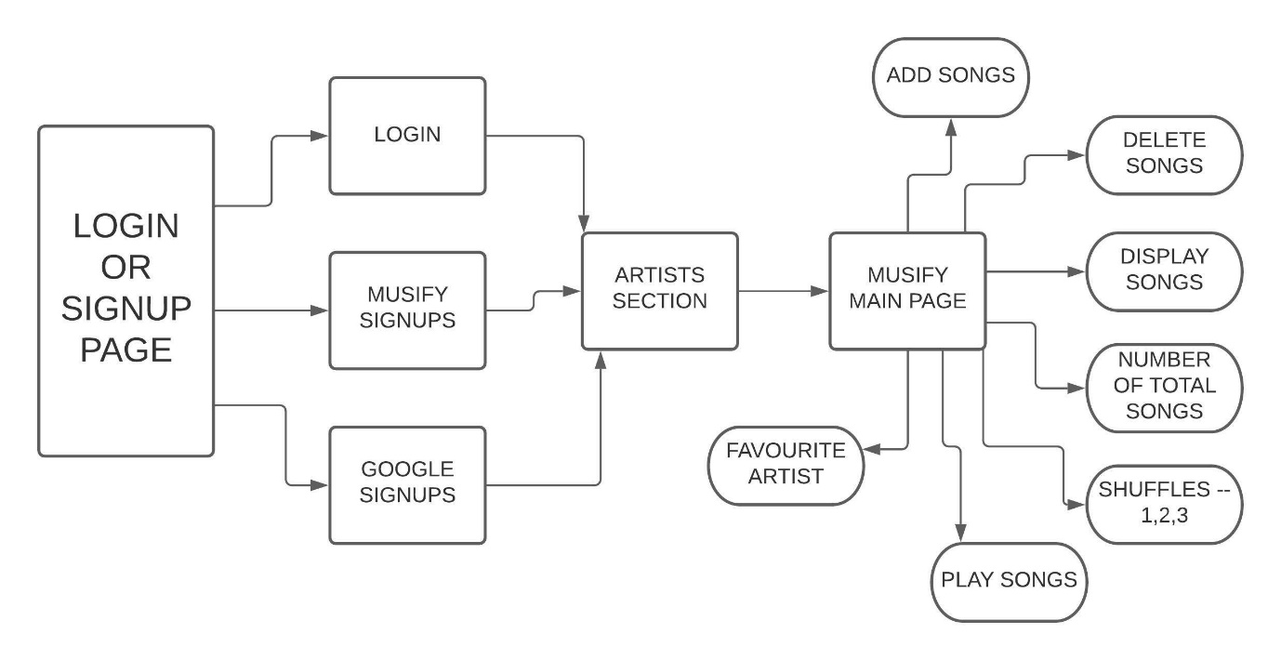

Code snippet with functionality discussion

#include<bits/stdc++.h>

#include<cstring>

#include<conio.h>

#include<stdlib.h>

#include<iostream>

#include<windows.h>

#include<mmsystem.h>

using namespace std;

int arr[12],i,j;

long long mob,b;

string name,gid="",sub="",mid,mpass,a;

char c;

queue<int> q;

struct node

{

    int data;

    node* left;

    node* right;

};

struct Node

{

    int key;

    struct Node *next;

    struct Node *prev;

};

Node*nnode,*current,*start=NULL;

void playSong(int p)

{

    if(p==1)

        PlaySound(TEXT("Jugnu.wav"),NULL,SND_SYNC);

    else if(p==2)

        PlaySound(TEXT("Genda Phool.wav"),NULL,SND_SYNC);

    else if(p==3)

        PlaySound(TEXT("Love Dose.wav"),NULL,SND_SYNC);

    else if(p==4)

        PlaySound(TEXT("Blue Eyes.wav"),NULL,SND_SYNC);

    else if(p==5)

        PlaySound(TEXT("Lehanga.wav"),NULL,SND_SYNC);

    else if(p==6)

        PlaySound(TEXT("No Competition.wav"),NULL,SND_SYNC);

    else if(p==7)

        PlaySound(TEXT("Tu Aake Dekhle.wav"),NULL,SND_SYNC);

    else if(p==8)

        PlaySound(TEXT("Tera Hua Na Kabhi.wav"),NULL,SND_SYNC);

    else if(p==9)

        PlaySound(TEXT("Mile Ho Tum.wav"),NULL,SND_SYNC);

    else if(p==10)

        PlaySound(TEXT("Manali Trance.wav"),NULL,SND_SYNC);

    else if(p==11)

        PlaySound(TEXT("Phir Bhi Tumko Chahunga.wav"),NULL,SND_SYNC);

    else if(p==12)

        PlaySound(TEXT("Tum Hi Ho.wav"),NULL,SND_SYNC);

    else

        cout<<"No song found."<<endl;

}

void display(int key,int j)

{

    if(key==1)

        cout<<j<<") JUGNU - BADSHAH"<<endl;

    if(key==2)

        cout<<j<<") GENDA PHOOL - BADSHAH"<<endl;

    if(key==3)

        cout<<j<<") LOVE DOSE - YO YO HONEY SINGH"<<endl;

    if(key==4)

        cout<<j<<") BLUE EYES - YO YO HONEY SINGH"<<endl;

    if(key==5)

        cout<<j<<") LEHNGA - JASS MANAK"<<endl;

    if(key==6)

        cout<<j<<") NO COMPETITION - JASS MANAK"<<endl;

    if(key==7)

        cout<<j<<") TU AAKE DEKHLE - KING"<<endl;

    if(key==8)

        cout<<j<<") TERA HUA NA MAI KABHI - KING"<<endl;

    if(key==9)

        cout<<j<<") MILE HO TUM HUMKO - NEHA KAKKAR"<<endl;

    if(key==10)

        cout<<j<<") MANALI TRANCE - NEHA KAKKAR"<<endl;

    if(key==11)

        cout<<j<<") PHIR BHI TUMKO CHAHUNGA - ARIJIT SINGH"<<endl;

    if(key==12)

        cout<<j<<") TUM HI HO - ARIJIT SINGH"<<endl;

}

void showq(queue<int> q)

{

    queue<int> g = q;

    while (!g.empty())

    {

        cout << '\t' << g.front();

        g.pop();

    }

    cout << '\n';

}

node* search(node* root,int key)

{

    node* temp;

    if(root==NULL)

        return root;

    if(root->data>key)

        root->left=search(root->left,key);

    else if(root->data==key)

    {

        cout<<"Song found"<<endl;

        return root;

    }

    else

        root->right=search(root->right,key);

}

int totalSongs(Node* start)

{

    int total=0;

    Node* temp=new Node;

    temp=start;

    while(temp!=NULL)

    {

        total=total+1;

        temp=temp->next;

    }

    cout<<"\n\n";

    return total;

}

void printPlayList(Node* start)

{

    int j=0;

    Node* temp=new Node;

    temp=start;

    while(temp!=NULL)

    {

        j++;

        display(temp->key,j);

        temp=temp->next;

    }

    cout<<"\n\n";

}

Node* deletemenu(Node* start,int del)

{

    if(del>12)

    {

        cout<<"SONG DOESN'T EXISTS IN PLAYLIST"<<endl;

        return start;

    }

    Node* temp,*temp1,*temp2;

    if(start==NULL)

    {

        cout<<"Playlist empty"<<endl;

        return start;

    }

    else if(start->key==del && start->next==NULL && start->prev==NULL)

    {

        start=NULL;

        cout<<"SONG DELETED"<<endl;

        return start;

    }

    else if(start->key==del && start->next!=NULL)

    {

        temp=start;

        start=start->next;

        start->prev=NULL;

        temp->next=NULL;

        delete temp;

        cout<<"SONG DELETED"<<endl;

        return start;

    }

    else

    {

        temp=start->next;

        while(temp!=NULL)

        {

            if(temp->key==del)

            {

                if(temp->next==NULL)

                {

                    temp1=temp->prev;

                    temp->prev=NULL;

                    temp1->next=NULL;

                    delete temp;

                }

                else

                {

                    temp1=temp->prev;

                    temp2=temp->next;

                    temp->next=NULL;

                    temp->prev=NULL;

                    temp1->next=temp2;

                    temp2->prev=temp1;

                    delete temp;

                    cout<<"SONG DELETED"<<endl;

                    return start;

                }

            }

            else

                temp=temp->next;

        }

        cout<<"SONG DOESN'T EXISTS IN PLAYLIST"<<endl;

        return start;

    }

}

Node* addNode(Node* start)

{

    nnode=new Node;

    cout<<"Enter your choice:\t";

    cin>>nnode->key;

    nnode->next=NULL;

    nnode->prev=NULL;

    if(start==NULL)

    {

        current=nnode;

        start=nnode;

    }

    else

    {

        current->next=nnode;

        nnode->prev=current;

        current=nnode;

    }

    cout<<"SONG SUCCESSFULLY ADDED."<<endl;

    return start;

}

void lists()

{

    cout<<"\t\t\t************THESE ARE THE LATEST HITS YOU CAN ADD IN YOUR PLAYLIST***********"<<endl;

    cout<<"1.  JUGNU - BADSHAH"<<endl;

    cout<<"2.  GENDA PHOOL - BADSHAH"<<endl;

    cout<<"3.  LOVE DOSE - YO YO HONEY SINGH"<<endl;

    cout<<"4.  BLUE EYES - YO YO HONEY SINGH"<<endl;

    cout<<"5.  LEHANGA - JASS MANAK"<<endl;

    cout<<"6.  COMPETITION - JASS MANAK"<<endl;

    cout<<"7.  TU AAKE DEKHLE - KING"<<endl;

    cout<<"8.  TERA HUA NA MAI KABHI - KING"<<endl;

    cout<<"9.  MILE HO TUM HUMKO - NEHA KAKKAR"<<endl;

    cout<<"10. MANALI TRANCE - NEHA KAKKAR"<<endl;

    cout<<"11. PHIR BHI TUMKO CHAHUNGA - ARIJIT SINGH"<<endl;

    cout<<"12. TUM HI HO - ARIJIT SINGH"<<endl;

}

void favPlaylist(int arr[12])

{

    int f=0;

    cout<<"Your favourite songs are : "<<endl<<endl;

    for(i=0; i<12; i++)

    {

        if(arr[i]==1)

            cout<<"JUGNU - BADSHAH"<<endl;

        else if(arr[i]==2)

            cout<<"GENDA PHOOL - BADSHAH"<<endl;

        else if(arr[i]==3)

            cout<<"LOVE DOSE - YO YO HONEY SINGH"<<endl;

        else if(arr[i]==4)

            cout<<"BLUE EYES - YO YO HONEY SINGH"<<endl;

        else if(arr[i]==5)

            cout<<"LEHANGA - JASS MANAK"<<endl;

        else if(arr[i]==6)

            cout<<"COMPETITION - JASS MANAK"<<endl;

        else if(arr[i]==7)

            cout<<"TU AAKE DEKHLE - KING"<<endl;

        else if(arr[i]==8)

            cout<<"TERA HUA NA MAI KABHI - KING"<<endl;

        else if(arr[i]==9)

            cout<<"MILE HO TUM HUMKO - NEHA KAKKAR"<<endl;

        else if(arr[i]==10)

            cout<<"MANALI TRANCE - NEHA KAKKAR"<<endl;

        else if(arr[i]==11)

            cout<<"PHIR BHI TUMKO CHAHUNGA - ARIJIT SINGH"<<endl;

        else if(arr[i]==12)

            cout<<"TUM HI HO - ARIJIT SINGH"<<endl;

        else;

    }

    for(i=0; i<12; i++)

    {

        if(arr[i]!=0)

        {

            f=f+1;

        }

    }

    if(f==0)

    {

        cout<<"Empty Favourite Artist's Playlist"<<endl<<endl;

    }

}

void preorder(node* root)

{

    if(root!=NULL)

    {

        display(root->data,root->data);

        preorder(root->left);

        preorder(root->right);

    }

}

void postorder(node* root)

{

    if(root!=NULL)

    {

        postorder(root->left);

        postorder(root->right);

        display(root->data,root->data);

    }

}

void inorder(node* root)

{

    if(root!=NULL)

    {

        inorder(root->left);

        display(root->data,root->data);

        inorder(root->right);

    }

}

node * n_node,*root=NULL;

node* insert(node* root,int key)

{

    n_node=new node;

    n_node->data=key;

    n_node->left=NULL;

    n_node->right=NULL;

    if(root==NULL)

    {

        root=n_node;

    }

    else

    {

        if(n_node->data<root->data)

        {

            if(root->left==NULL)

                root->left=n_node;

            else

                insert(root->left,n_node->data);

        }

        else

        {

            if(root->right==NULL)

                root->right=n_node;

            else

                insert(root->right,n_node->data);

        }

    }

    return root;

}

void load(int a)

{

    int v;

    for(int h=0; h<a; h++)

    {

        v=0;

    }

}

void loading()

{

    cout<<"LOADING";

    for(int j=0; j<21; j++)

    {

        load(9999999);

        cout<<" .";

    }

    cout<<"\n";

    system("cls");

}

void artists()

{

    loading();

    cout<<"\t\t\t\t***** WELCOME TO ARTISTS SECTION *****"<<endl<<endl;

    cout<<"\t\t *****HERE YOU CAN CHOOSE YOUR FAVOURITE ARTISTS AND THEIR SONGS *****"<<endl<<endl;

    cout<<"\tENTER 'SKIP' TO SKIP, ANY OTHER KEY TO CONTINUE : \t";

    cin>>a;

    transform(a.begin(),a.end(),a.begin(),::tolower);

    if(a=="skip")

    {

        cout<<"\t\t\t\t**************************************"<<endl;

        cout<<"\t\t\t\t\tWELCOME TO MUSIFY     "<<endl;

        cout<<"\t\t\t\t**************************************"<<endl<<endl<<endl;

    }

    else

    {

        cout<<"\nSELECT YOUR FAVOURITE ARTIST (1 at a time) FROM THE FAMOUS ARTISTS!!"<<endl<<endl;

        cout<<"\n1. BADSHAH - Most Viewed Song <<Genda Phool>>\n\n2. YO YO HONEY SINGH - Most Viewed Song <<Dheere Dheere>>"<<endl;

        cout<<"\n3. JASS MANAK - Most Viewed Song <<Lehnga>>\n\n4. KING - Most Viewed Song <<Tu Aake Dekhle>>"<<endl;

        cout<<"\n5. NEHA KAKKAR - Most Viewed Song <<Mile Ho Tum Humko>>\n\n6.ARIJIT SINGH - Most Viewed Song <<Phir Bhi Tumko Chahunga>>"<<endl<<endl;

        cout<<"Enter your choice - \t";

        cin>>a;

        if(a=="1")

        {

            arr[0]=1;

            arr[1]=2;

        }

        else if(a=="2")

        {

            arr[2]=3;

            arr[3]=4;

        }

        else if(a=="3")

        {

            arr[4]=5;

            arr[5]=6;

        }

        else if(a=="4")

        {

            arr[6]=7;

            arr[7]=8;

        }

        else if(a=="5")

        {

            arr[8]=9;

            arr[9]=10;

        }

        else if(a=="6")

        {

            arr[10]=11;

            arr[11]=12;

        }

        else

            cout<<"Wrong choice."<<endl;

    }

    loading();

    favPlaylist(arr);

}

void googleSignUps()

{

    loading();

    cout<<"Enter your gmail id :\t";

    fflush(stdin);

    getline(cin,gid);

    b=gid.size();

    if(b<10)

    {

        cout<<"Invalid gmail id.... Gmail id always ends with @gmail.com!!"<<endl;

        cout<<"Reloading the Google Signup Page."<<endl<<endl;

        cout<<"\t\t\t<<PRESS ANY KEY TO CONTINUE>>"<<endl;

        cin>>c;

        googleSignUps();

    }

    else

    {

        sub=gid.substr(b-10,b);

        if(sub!="@gmail.com")

        {

            cout<<"Invalid gmail id.... Gmail id always ends with @gmail.com!!"<<endl;

            cout<<"Reloading the Google Signup Page."<<endl<<endl;

            cout<<"\t\t\t<<PRESS ANY KEY TO CONTINUE>>"<<endl;

            cin>>c;

            googleSignUps();

        }

        else

        {

            cout<<"Enter password :\t";

            cin>>mpass;

            cout<<"Creating account!!!!";

            for(int j=0; j<21; j++)

            {

                load(9999999);

                cout<<" .";

            }

            cout<<"\nAccount created successfully!!"<<endl;

            cout<<"\nEnter any key to continue."<<endl;

            cin>>a;

        }

    }

}

void musifySignUps()

{

    loading();

    cout<<"\t\t\t\t**************************************"<<endl;

    cout<<"\t\t\t\t\tWELCOME TO MUSIFY SIGNUPS     "<<endl;

    cout<<"\t\t\t\t**************************************"<<endl<<endl<<endl;

    cout<<"\nEnter your name :\t";

    fflush(stdin);

    getline(cin,name);

    cout<<"\nEnter your mobile number :\t";

    cin>>mob;

    cout<<"\nEnter any key to generate your UNIQUE MUSIFY ID by MUSIFY itself."<<endl;

    cin>>a;

    cout<<"LOADING";

    for(int j=0; j<21; j++)

    {

        load(9999999);

        cout<<" .";

    }

    cout<<"\n";

    cout<<"Your UNIQUE MUSIFY ID is : 'AZS41000'. Remember this for future logins."<<endl;

    cout<<"Your UNIQUE password is same as your UNIQUE MUSIFY ID."<<endl;

    cout<<"Creating account!!!!";

    for(int j=0; j<21; j++)

    {

        load(9999999);

        cout<<" .";

    }

    cout<<"\nAccount created successfully!!"<<endl;

    cout<<"\nEnter any key to continue."<<endl;

    fflush(stdin);

    cin>>a;

}

void signup()

{

    loading();

    cout<<"\t\t\t\t***********************************"<<endl;

    cout<<"\t\t\t\t\tWELCOME TO SIGNUP PAGE     "<<endl;

    cout<<"\t\t\t\t***********************************"<<endl<<endl;

    cout<<"\t\t\t\t<<<<<<<<<<  SIGNUP NOW  >>>>>>>>>>>"<<endl<<endl;

    cout<<"Listen to all your favourite songs for free on Musify."<<endl<<endl;

    cout<<"Press 1 for 'MUSIFY SIGNUPS'"<<endl;

    cout<<"           OR               "<<endl;

    cout<<"Press any other key to sign up with Google Account"<<endl;

    cin>>a;

    if(a=="1")

        musifySignUps();

    else

        googleSignUps();

}

void login()

{

    cout<<"Enter your Musify I'd :\t\t";

    cin>>mid;

    b=mid.size();

    if(b<=3)

    {

        cout<<"\n\t'"<<mid<<"' is not a valid Musify I'd!!"<<endl;

        cout<<"\tMusify Id always ends with '000'"<<endl;

        cout<<"\tTry to LOGIN AGAIN...."<<endl<<endl;

        login();

    }

    else

    {

        sub=mid.substr(b-3,b);

        if(sub=="000")

        {

            cout<<"Enter password for your musify ID :\t";

            fflush(stdin);

            getline(cin,mpass);

            if(mid==mpass)

            {

                loading();

            }

            else

            {

                cout<<"WRONG PASSWORD.... "<<endl<<endl;

                cout<<"If you forgot your password you can create a new account for free...."<<endl<<endl;

                cout<<"Press 1 to login again."<<endl;

                cout<<"Press 2 for signing up for a new account."<<endl;

                cin>>a;

                if(a=="1")

                    login();

                else if(a=="2")

                    signup();

                else

                {

                    cout<<"Invalid choice...."<<endl;

                    cout<<"Returning to login page again...."<<endl;

                    cout<<"<<Press any key to continue>>"<<endl;

                    cin>>a;

                    login();

                }

            }

        }

        else

        {

            cout<<"\n\t'"<<mid<<"' is not a valid Musify I'd!!"<<endl;

            cout<<"\tMusify Id always ends with '000'"<<endl;

            cout<<"\tTry to LOGIN AGAIN...."<<endl<<endl;

            login();

        }

    }

}

int main()

{

    for(int i=0; i<12; i++)

    {

        arr[i]=0;

    }

    cout<<"LOADING";

    for(int j=0; j<21; j++)

    {

        load(9999999);

        cout<<" .";

    }

    cout<<"\n";

    system("cls");

    root=insert(root,6);

    root=insert(root,1);

    root=insert(root,2);

    root=insert(root,11);

    root=insert(root,7);

    root=insert(root,8);

    root=insert(root,12);

    root=insert(root,3);

    root=insert(root,4);

    root=insert(root,9);

    root=insert(root,5);

    root=insert(root,10);

    cout<<"\t\t\t\t***********************************"<<endl;

    cout<<"\t\t\t\t\tWELCOME TO LOGIN PAGE     "<<endl;

    cout<<"\t\t\t\t***********************************"<<endl<<endl<<endl;

    login();

    artists();

    int c,d,p,total=0;

    char choice;

    string strin;

    cout<<"\t\t\t\t**************************************"<<endl;

    cout<<"\t\t\t\t\tWELCOME TO MUSIFY     "<<endl;

    cout<<"\t\t\t\t**************************************"<<endl<<endl<<endl;

    cout<<"Listen to all your favourite songs for free on Musify."<<endl<<endl;

    cout<<"\n\nEnter your playlist name-  ";

    fflush(stdin);

    getline(cin,strin);

    do

    {

        cout<<"\n(a)Add new song in your playlist.\n(b)Delete Song from your Playlist.\n(c)Display Entered Playlist.\n(d)Total Songs in playlist.\n(e)Shuffle1.\n(f)Shuffle2.\n(g)Shuffle3.\n(h)Search.\n(i)Recently Searched Songs.\n(j)Play Any Song.\n(k)Favourite Artist's Songs.\n(l)Exit.\n"<<endl;

        cout<<("\nEnter your choice- ");

        cin>>choice;

        switch(choice)

        {

        case 'a':

            lists();

            start=addNode(start);

            break;

        case 'b':

            cout<<"Enter the number of song to be deleted"<<endl;

            fflush(stdin);

            cin>>c;

            start=deletemenu(start,c);

            break;

        case 'c':

            printPlayList(start);

            break;

        case 'd':

            total=totalSongs(start);

            cout<<total<<endl<<endl;

            break;

        case 'e':

            preorder(root);

            break;

        case 'f':

            postorder(root);

            break;

        case 'g':

            inorder(root);

            break;

        case 'h':

            lists();

            cout<<"Enter the song to be searched :\t";

            cin>>d;

            q.push(d);

            root=search(root,d);

            break;

        case 'i':

            showq(q);

            break;

        case 'j':

            lists();

            cout<<"Enter song to be played for you:\t";

            cin>>p;

            playSong(p);

            break;

        case 'k':

            favPlaylist(arr);

            break;

        case 'l':

            exit(0);

        }

    }

    while(choice!='z');

    return 0;

}

OUTPUTS AND DISCUSSION:

The first page that comes up in our app is the login page. For successful login, one has to enter his/her unique musify ID that was generated while signing up for the same. Musify unique ID always ends up with “000” at the end.

**LOGIN PAGE:**

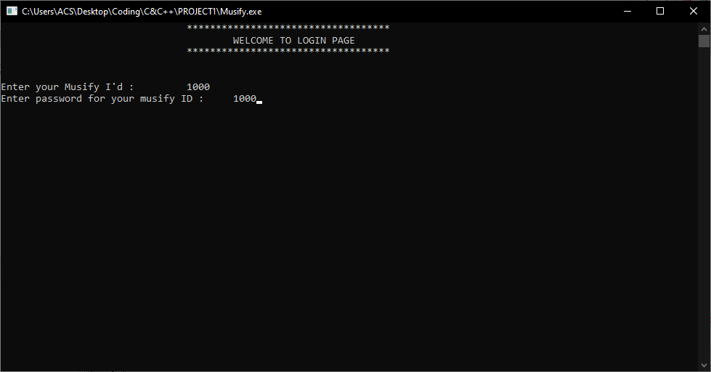

If by chance any user forgets the password or Musify ID then the musifier can sign up for a new account and can start a new journey of songs. Signups are as easy as they seems to be. There are two ways to directly signup for a new account. First being the Google SignUps and second being the Musify SignUps. For Musify SignUps, the only requirements are a valid phone number and name. For Google SignUps, one should have a prior Google Account.

**WAYS TO SIGNUP OR LOGIN:**

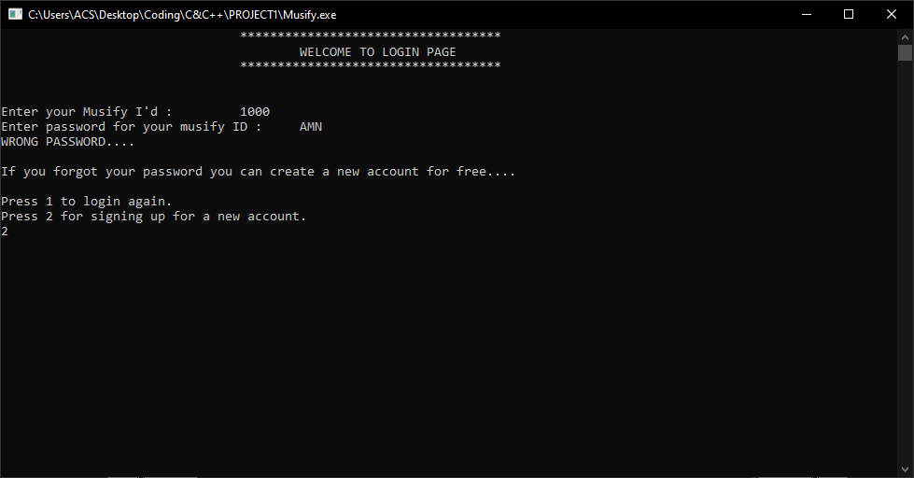

**MUSIFY SIGNUP PAGE:**

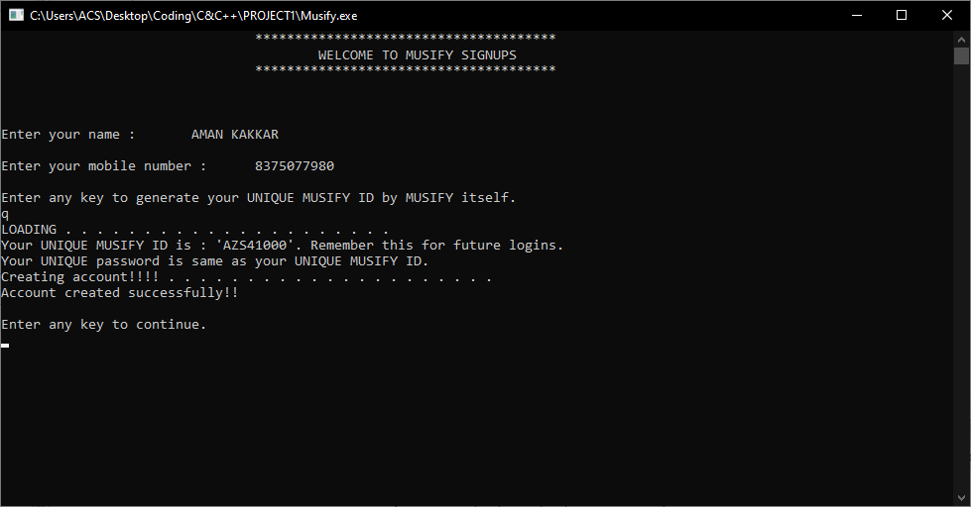

**GOOGLE SIGNUP PAGE:**

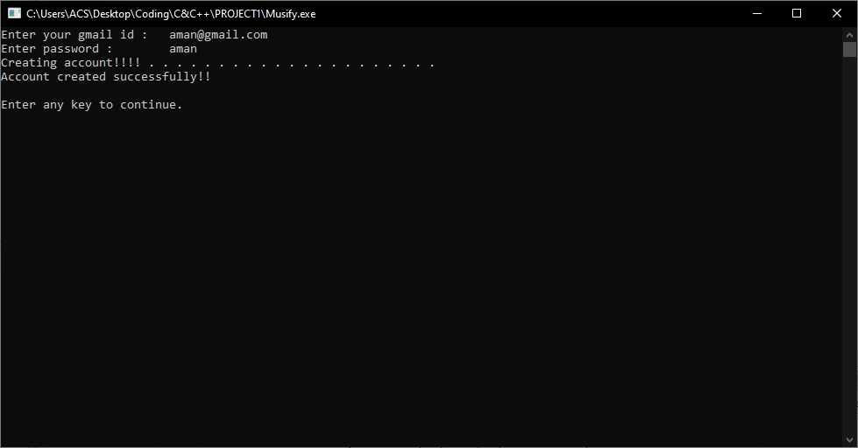

After successful login or signups, one has successfully entered the favourite artists section. Here user can choose the favourite artists available or can skip this page by just typing “skip”. This skip is not case sensitive so you can type skip in any way.

**ARTISTS SECTION:**

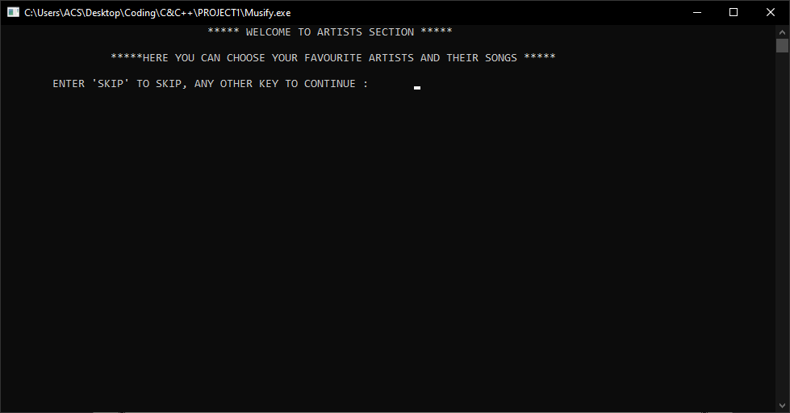

After choosing the favourite artist, all the songs available of that particular artist will be added in your favourite playlist. If you skip this page, no worries your favourite playlist will be displayed as empty.

**Example of artists section:**

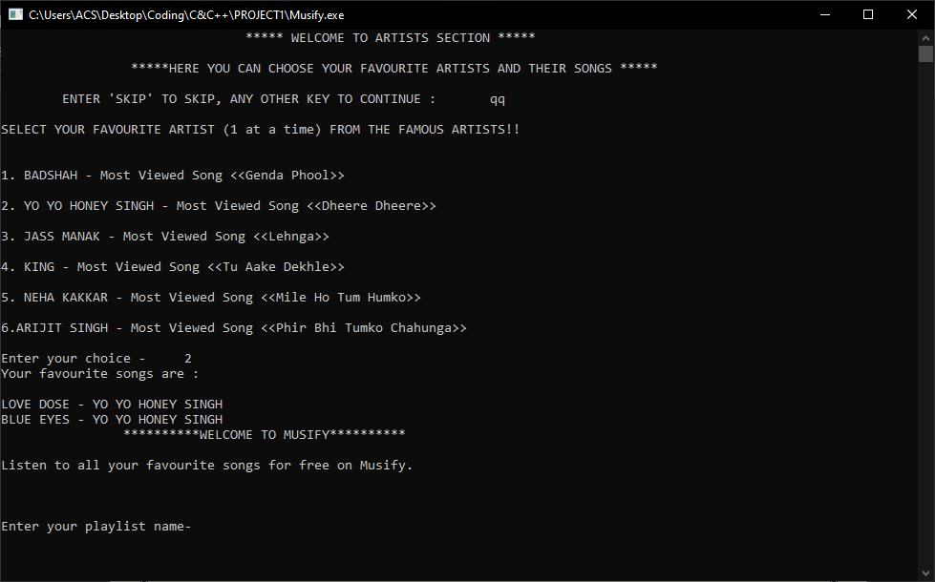

Here we get our fav playlist songs at the top of the Musify page. As of now we have managed to complete all the required things to enter the main interface of the app. We just need to add the out playlist name here and whoohoo!!

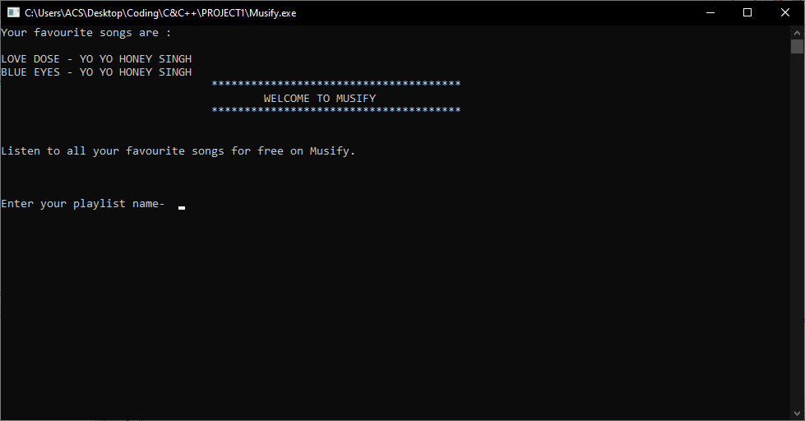

After entering the playlist name, now we can add songs in our own playlist by just typing ‘a’. A list of all the songs available will be shown and you can add songs in the playlist.

**ADDING SONGS IN PLAYLIST:**

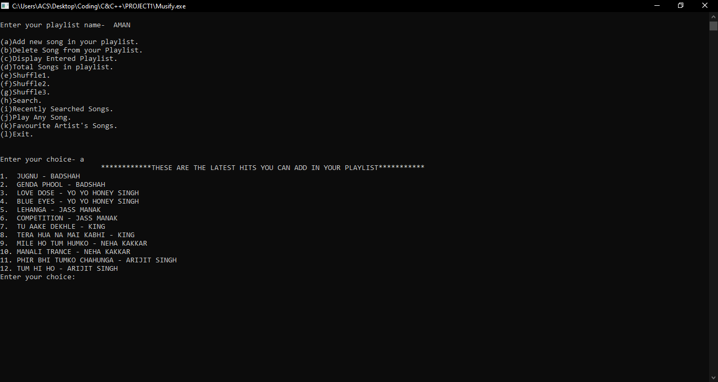

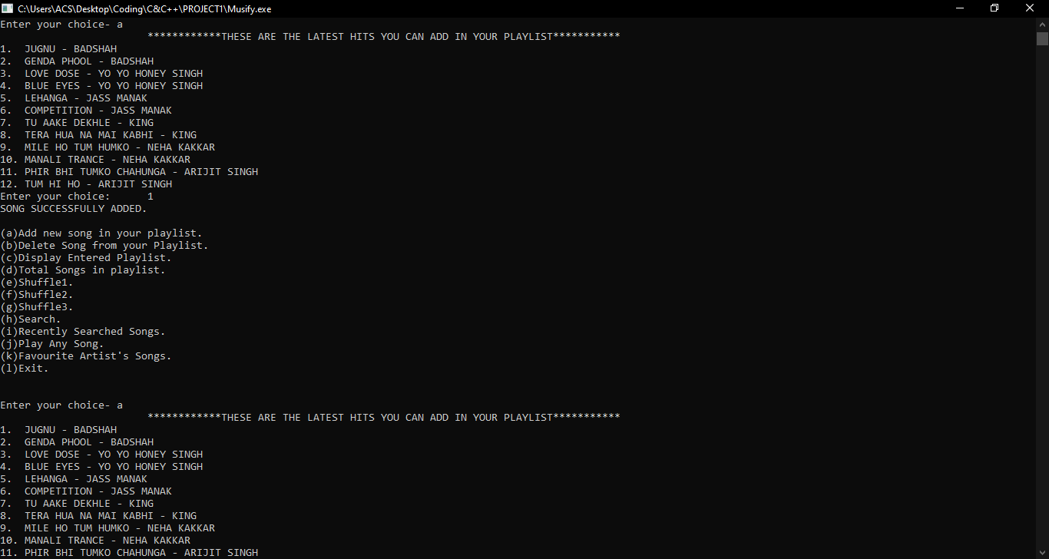

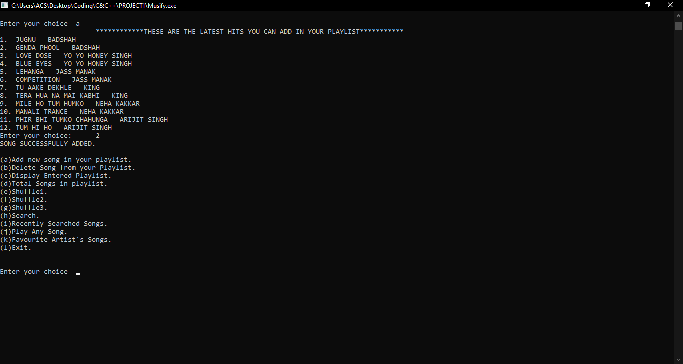

**DELETING SONGS FROM PLAYLIST:**

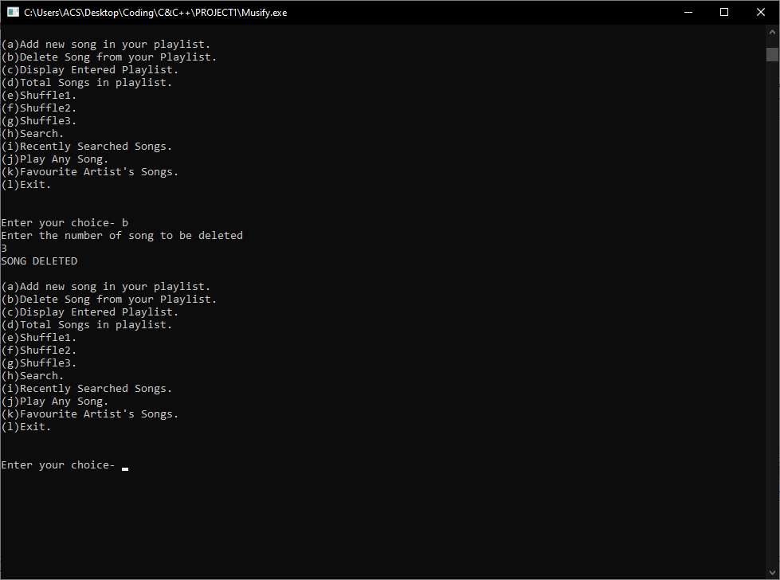

If somehow playlist is empty or you have deleted all the songs from the playlist, it will display the message that the playlist is empty.

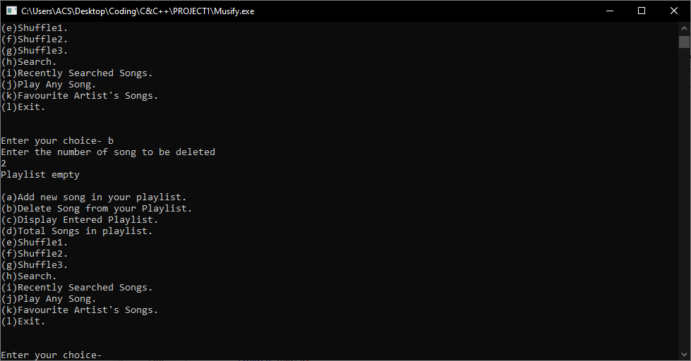

If song to be deleted isn’t found, then it displays the message- ‘Song doesn’t exists”.

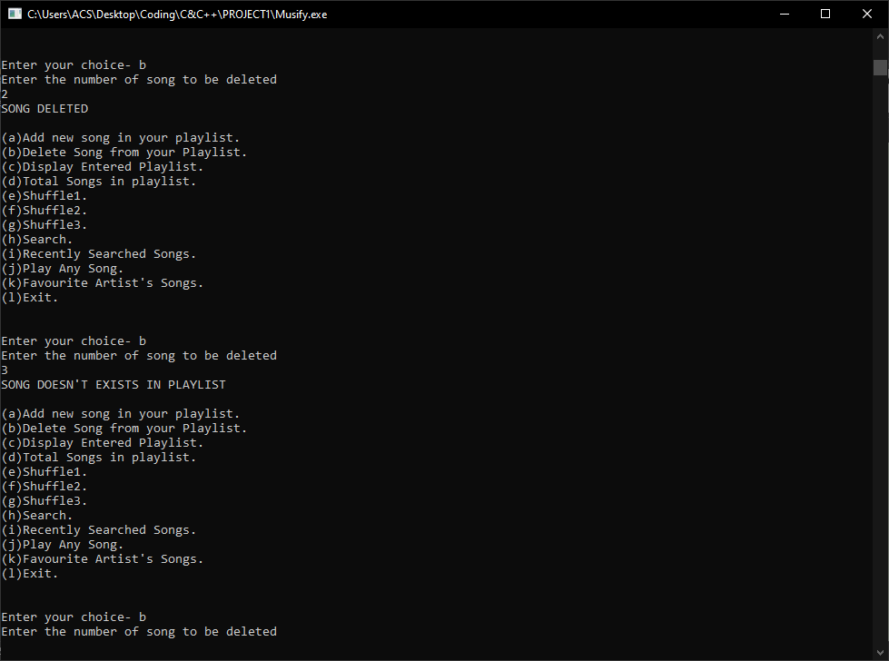

**DISPLAY ENTIRE PLAYLIST:**

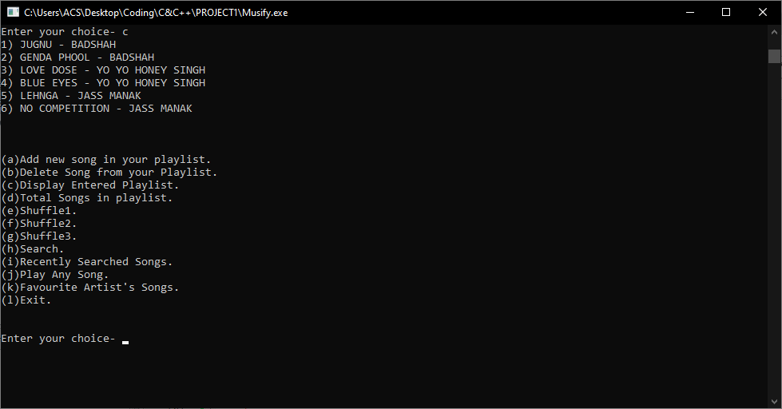

**DISPLAY NUMBER OF SONGS IN PS:**

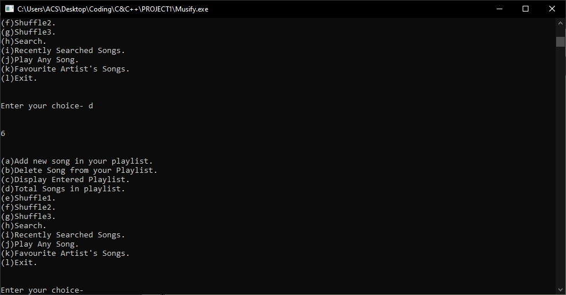

**TYPES OF SHUFFLES:**

**Shuffle1:**

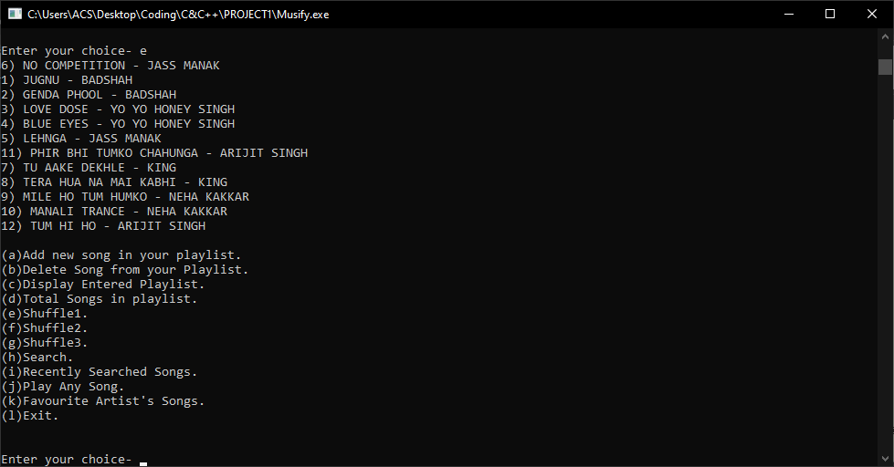

**Shuffle2:**

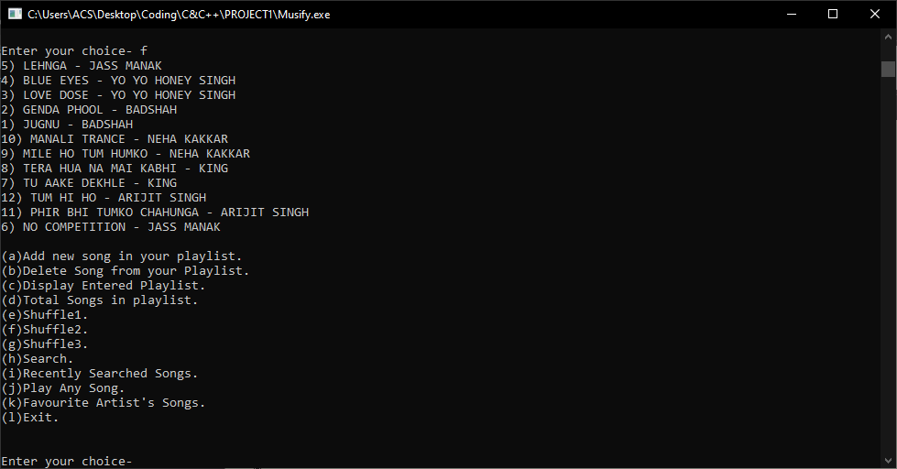

**Shuffle3:**

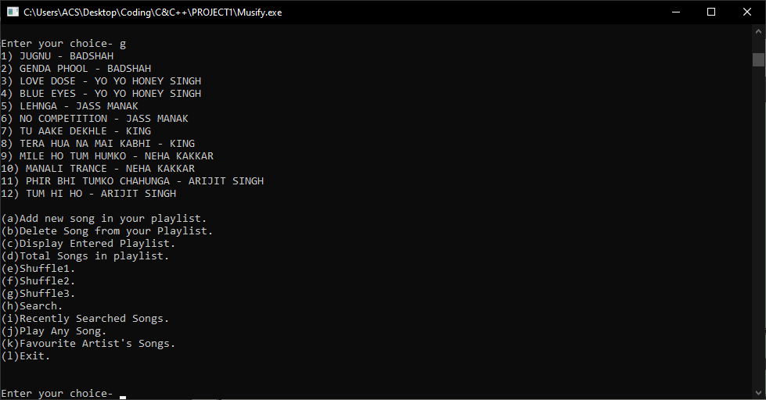

**Search any song on Musify:**

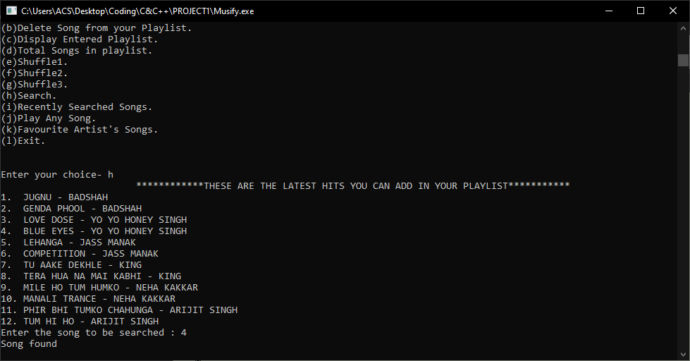

**Track your search history :**

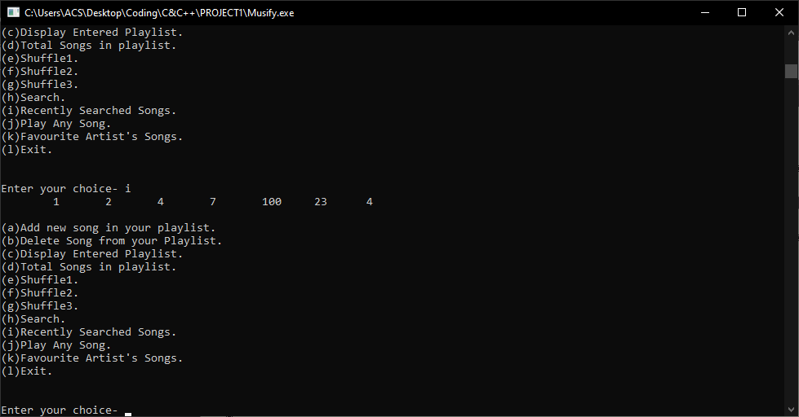

**Favourite Artist’s Section:**

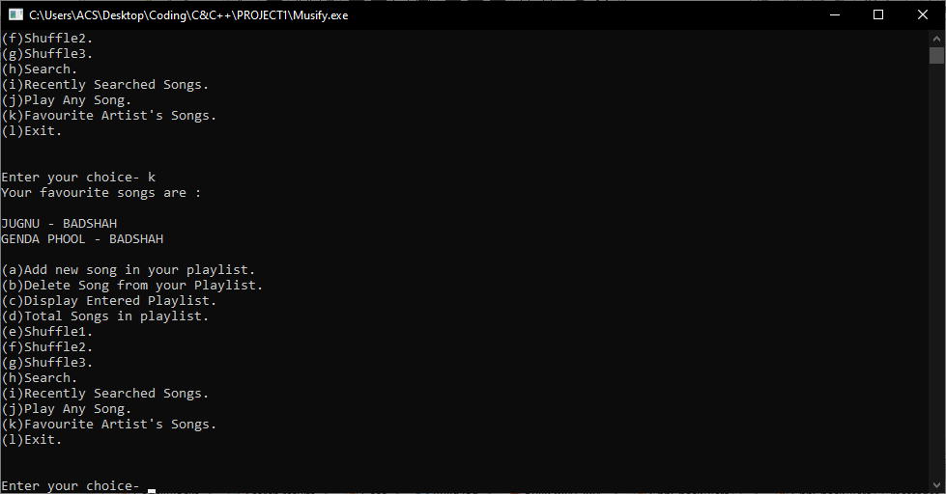

At the end, you can listen to our “Man chaha gaana” just by typing ‘j’ and choosing which song to play.

Hope you enjoy the tutorials and understood the concept of Musify completely.

**CONCLUSION AND FUTURE WORK:**

We aimed at creating a music player in which we can create, edit and delete our own playlist. We can also shuffle the songs or play the songs on loop. Moreover, we can see our search history just by going to the recently played option available. Our main objective is to create a user -friendly interface for better interaction with the musifiers. Our application will play an important role for the advancement of apps that are made for entertainment purposes.

We are going to add the artists section in the upcoming updates so that artists can earn money after there songs are played the required number of time. Also we will fix the bugs that will be sent to us through feedbacks.

**References**

* <https://www.geeksforgeeks.org/data-structures/>
* <https://www.youtube.com/playlist?list=PLu0W_9lII9ahIappRPN0MCAgtOu3lQjQi>
* <https://www.youtube.com/playlist?list=PLDN4rrl48XKpZkf03iYFl-O29szjTrs_O>
* **Slides provided by Prof. Ankita Wadhwa(IT FACULTY)**